# Instruction to Setup Data Collection in BlueJ

1. Install BlueJ ([www.bluej.org](http://www.bluej.org))
2. Upon first execution after installation, click on the **“I agree to take part, and I certify that I am 16 or older”** button when prompted. If this prompt is missing, move on to step 3.

## View on Mac View on Windows

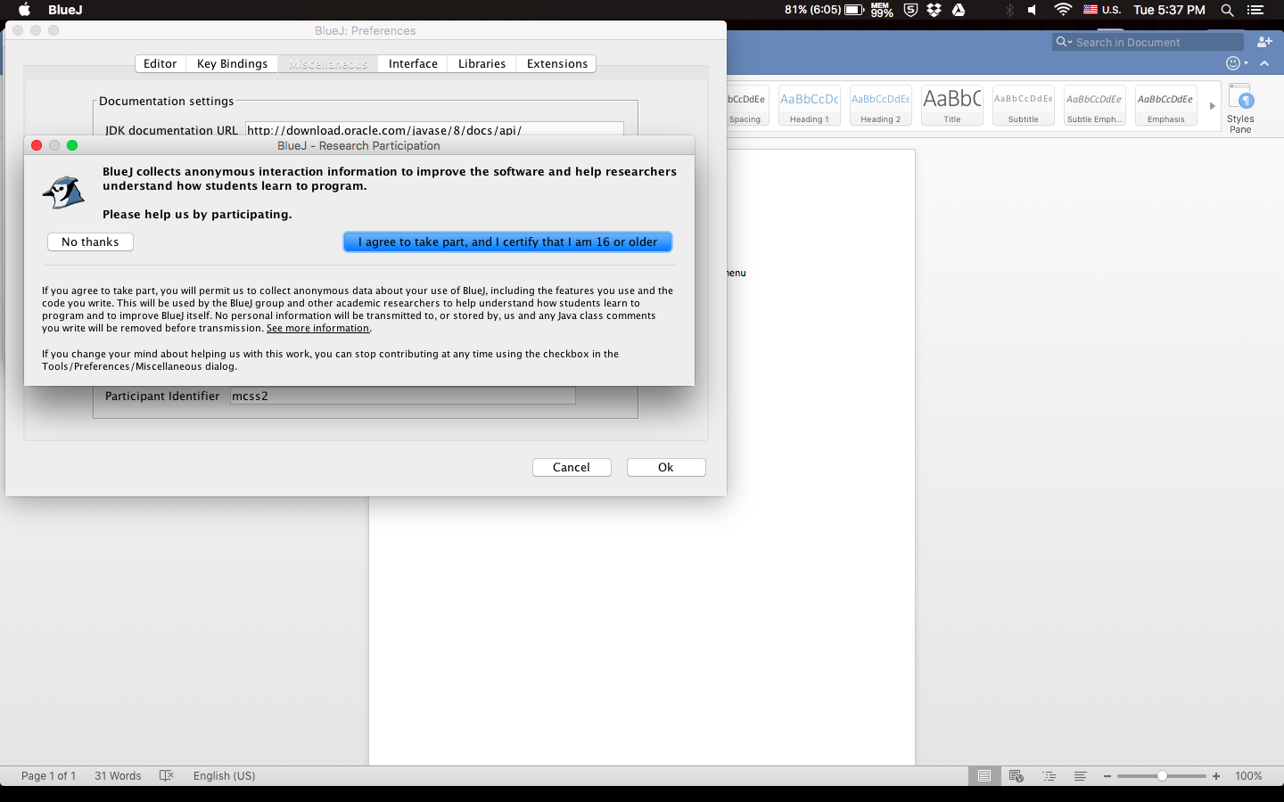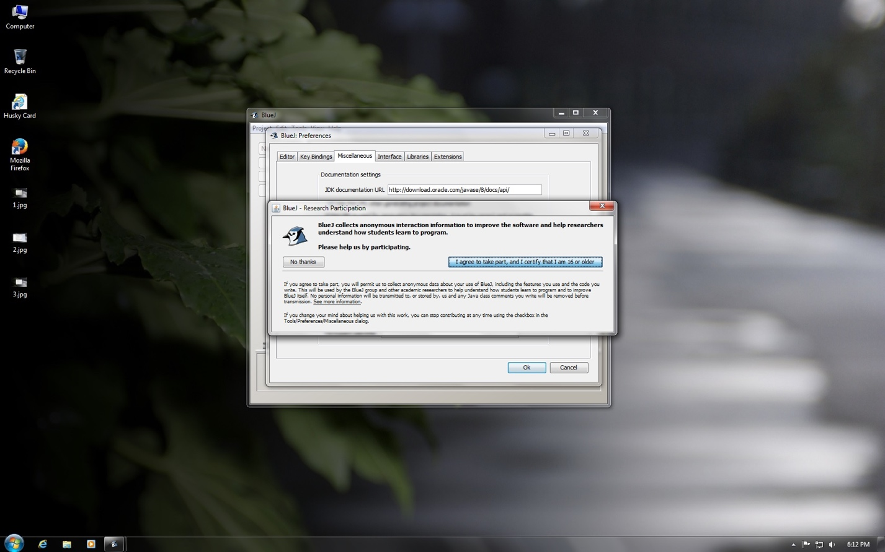

1. Click on **“Preferences”** from the BlueJ dropdown main menu (under Tools for Windows)

## View on Mac View on Windows

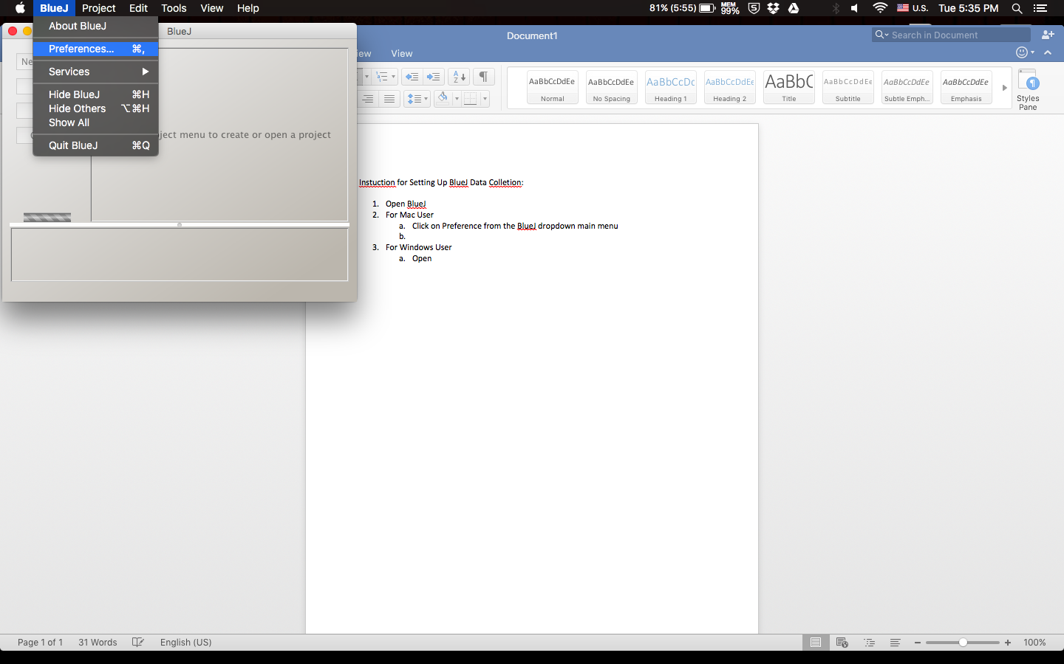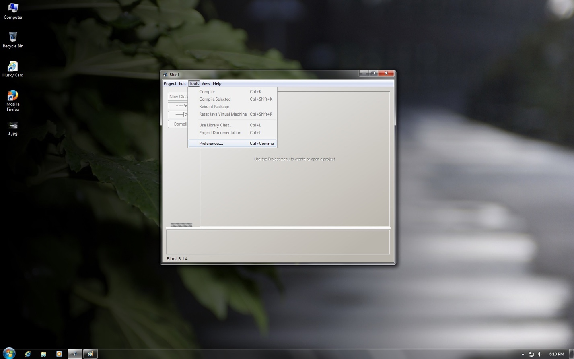

1. Click on the **“Miscellaneous”** Tab

## View on Mac View on Windows

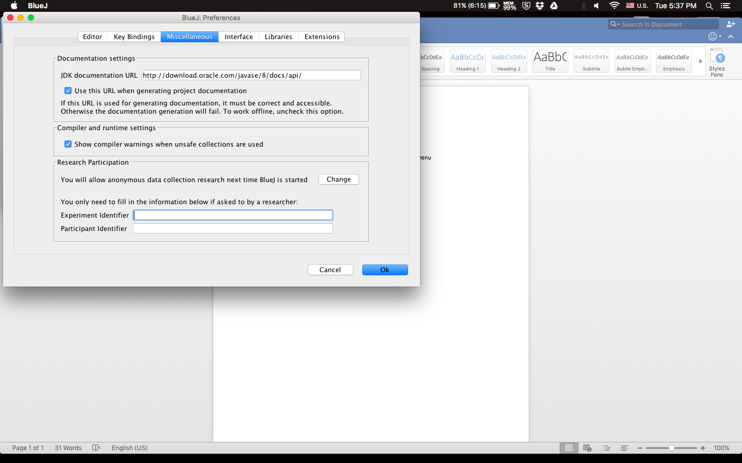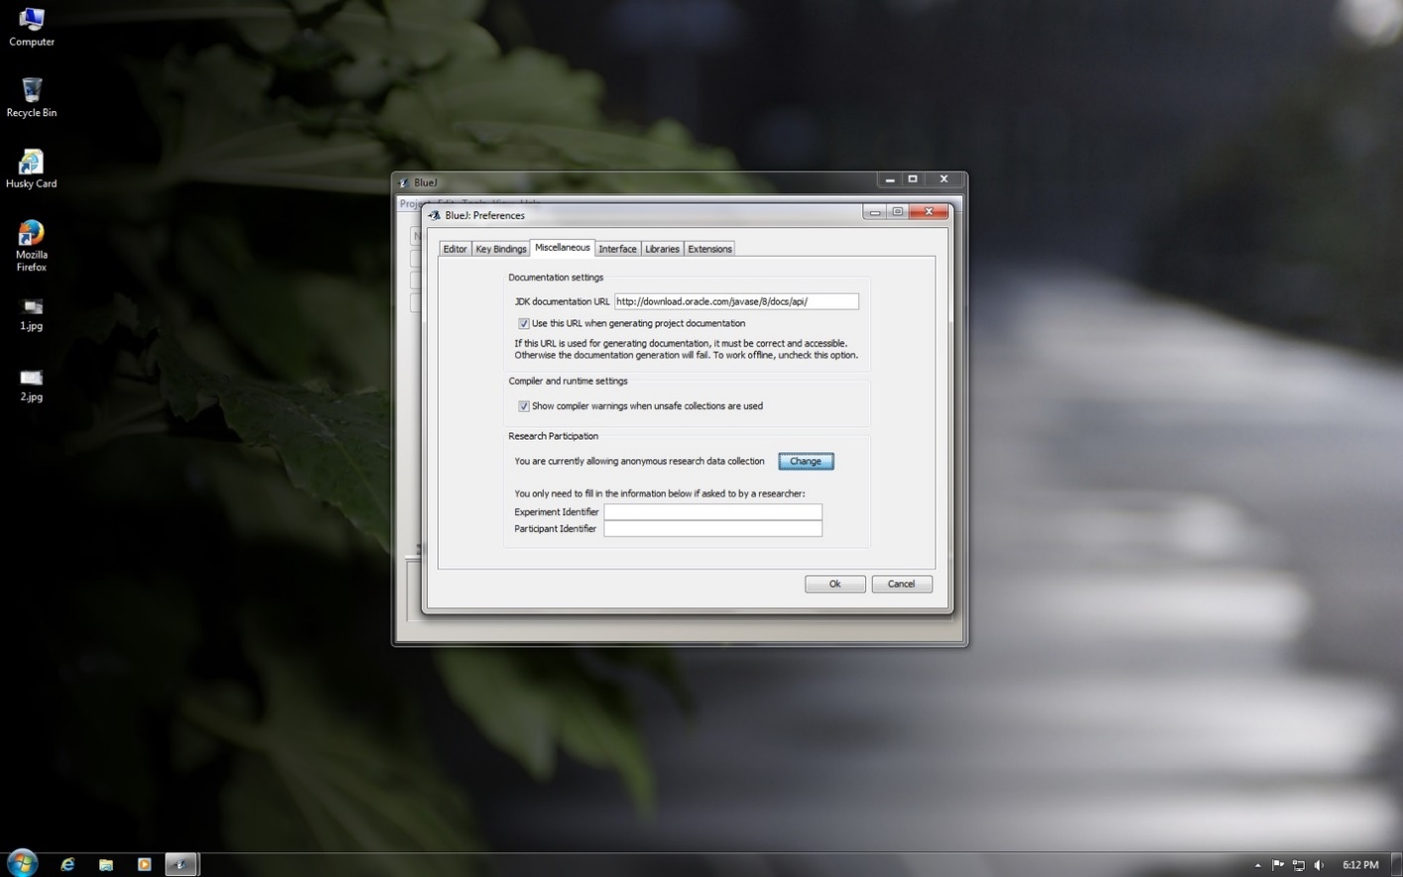

1. Skip this step if already prompted in step 2, else click on the **“Change”** button and then click on **“I agree to take part, and I certify that I am 16 or older”** button

## View on Mac View on Windows



1. Enter **“uwbgtcs”** into **“Experiment Identifier”**
2. Enter **“course + instructor LAST name”** into **“Participant Identifier”**, e.g. **“css161Nash”**

## View on Mac View on Windows

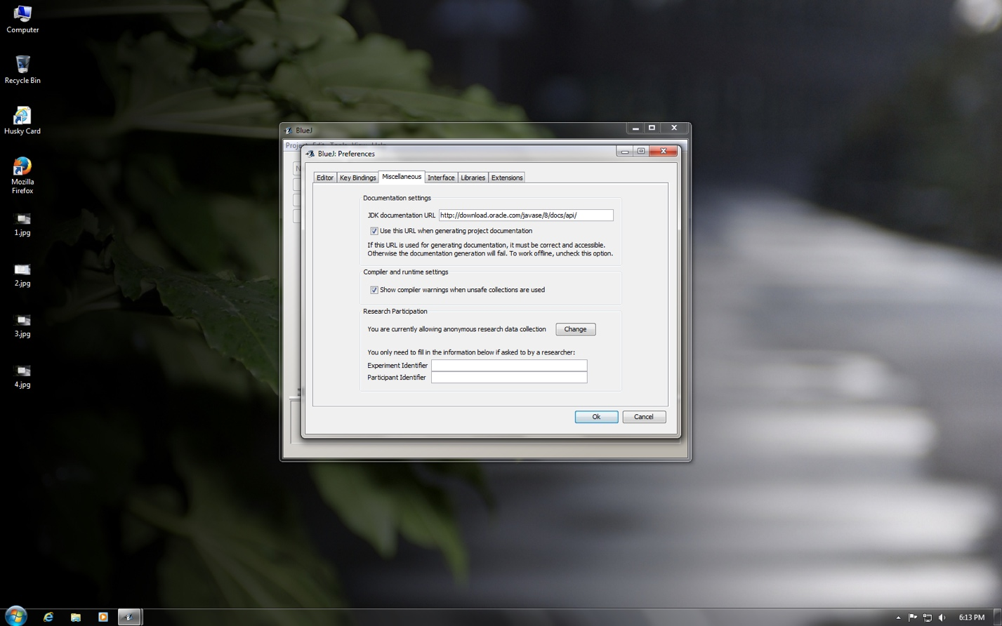



uwbgtcs

Css161Nash

1. Click **“Ok”**